# NAME OF THE PROJECT

Chesscake – Chess Robot

# GROUP MEMBERS

1806A016 – Tayfun Özçelik

1906A036 - Ceyhun Taha Karabıyık

2006A911 - Aierken Aikedan

20067046 - Muhammet Metehan Bozdemir

# MOTIVATION

As young and enthusiastic engineer candidates, we have two main motivations that lead us to build this project. First one is to contribute to the ongoing academic studies about robotics and artificial intelligence by developing our own solutions, and hopefully help humanity move towards a better future with more advanced technologies. Another one is to develop a product that could be a milestone in the entertainment industry, change current bad habits and help people to interact with new technologies in a more healthy way.

# USER REQUIREMENTS

End User:

1. The robot should accurately detect the boundaries, orientation, and position of the chessboard.
2. The robot should correctly recognize the letters and numbers on the board (mapping the board with letters and numbers).
3. The robot should accurately detect the checkered pattern on the board and map it using the recognized numbers and letters.
4. To verify the accuracy of specific moves, the robot should correctly distinguish and classify the colors of the squares that form the checkered pattern on the board.
5. It should identify the types of chess pieces and assign the appropriate moves to each piece type.
6. To ensure accurate moves and track move accuracy, the robot should differentiate the colors of the chess pieces and correctly classify them according to their colors.
7. For a seamless and smooth game experience, the robot should know the movement patterns of each piece and use them correctly.
8. The robot should be able to hold and place chess pieces independently to provide a good partnership to the user.
9. The device setup and preparation for the game should be simple and easy, allowing users to start the game quickly without dealing with technical details or complex steps.
10. It should be supportive and instructive for beginners, identifying incorrect moves, giving warnings, and suggesting possible moves.
11. The robot should be portable, enabling users to use it in different locations and take it with them on travels if necessary.
12. It should be storable, allowing users to place it in a box or cabinet when not in use to save space.
13. The robot should be easy to maintain, enabling users to quickly perform checks without needing technical expertise.
14. It should be budget-friendly, making it accessible to people from all walks of life as a hobby tool.
15. The robot should be durable against impacts and falls that may occur during daily use, providing a sense of security to the user.
16. It should be suitable for children, with an interface and control system that does not include complex structures they cannot understand.
17. The robot should offer a safe experience. It should not contain sharp edges or pointed parts that could cause injuries, and it should be designed to avoid damage to the user or surrounding objects in case of potential collisions. Proper electrical insulation should be ensured, avoiding issues like overheating and noisy operation.

Shipping and Storage Companies:

1. The product should be lightweight, making it easy for shipping and warehouse personnel to carry.
2. It should have a compact design, reducing costs in shipping and storage processes.
3. The robot should be impact-resistant, able to withstand minor collisions during transportation.
4. The packaging should facilitate easy storage and transport.

Sellers/Distributors:

1. The product should be marketable and competitive with similar products.
2. It should have a design and presentation that captures customers' interest.
3. It should offer different features that convince the customer.
4. The product should be reasonably priced and seen as an affordable option for customers.

Environmental Concerns:

1. The device should be made from recyclable or biodegradable materials.
2. It should not contain toxic substances or inhibitors that could harm ecosystems.
3. Rechargeable batteries or direct power connections should be preferred to avoid waste battery generation.
4. The product's packaging and protective equipment should be made from recyclable or biodegradable materials.
5. The product should not consume unnecessary power.
6. The device's parts should be repairable and replaceable, preventing the entire device from becoming waste due to minor regional damages.

# OBJECTIVES

Chess Playing:

* The robot should accurately detect the boundaries, orientation, and position of the chessboard and distinguish it from surrounding objects and the surface it is on.
* It should correctly recognize the letters and numbers on the board.
* The robot should accurately detect the checkered pattern on the board and map it using the recognized numbers and letters.
* To verify the accuracy of specific moves, the robot should correctly distinguish and classify the colors of the squares that form the checkered pattern on the board.
* It should identify the types of chess pieces, classify them, and assign the appropriate moves to each piece type.
* To ensure accurate moves and track move accuracy, the robot should differentiate the colors of the chess pieces and correctly classify them according to their colors.
* For a seamless and smooth game experience, the robot should know the movement patterns of each piece and use them correctly.
* The robot should be able to hold the chess pieces independently without damaging them and place them in the appropriate positions.
* It should be supportive and instructive for beginners, identifying incorrect moves, giving warnings, and suggesting possible moves.
* The robot should grasp the pieces without damaging them and place them correctly on the target position or off the board.
* It should detect when a user makes an incorrect move and warn them.
* The robot should have the ability to develop strategies to compete with the user and offer a satisfying experience.
* It should not move too slowly.
* The robot should quickly decide on and execute its moves without making the user wait too long.
* It should keep track of the move order.
* The robot should inform the user after each move.

Ease of Use and Maintenance:

* The robot should be easy to maintain.
* The setup and preparation for the game should be simple and easy, enabling users to start playing quickly without dealing with technical details or complex steps.
* It should have easy setup procedures.
* The robot should be easy to start.
* Broken or faulty components of the device should be easily replaceable, or such services should be provided.

Portability and Storability:

* The robot should have a compact design.
* It should easily fit into its box or a similar space after use.
* The device should be easily portable by a single individual and placeable in a specified position.
* It should be easy for shipping companies to transport.
* The robot should be easy to stack and store in shops or warehouses.
* The device should be sufficiently durable to withstand impacts that may occur during transport, avoiding quick damage and breakage.

Marketability:

* The robot should have a modern and attention-grabbing design/appearance.
* It should be competitively priced.
* The device should offer unique features that make it stand out and introduce new elements.

Safe Operation:

* The device should be electrically insulated and safe.
* It should not contain sharp or pointed parts that could cause injuries.
* Its movement speed should not cause pain upon impact.
* The robot should not collide with or damage surrounding objects.
* It should be easily deactivated with a single button in case of an emergency.
* The robot should not have surfaces that can harm the skin upon contact.

Eco-Friendly Design:

* It should be made of recyclable materials.
* The device should not engage in unnecessary power consumption.
* It should not contain toxic substances or paints.
* The device should be repairable, preventing it from becoming waste due to minor malfunctions.
* It should not cause waste battery generation.

# LITERATURE AND MARKET RESEARCH

Chess-playing robots can be used as an educational tool to help users improve their gaming skills but also enhance human-robot interaction.

In 1980 the first chess robot available for purchase was created. Named Boris Handroid. At the same time another robotic chess game was developed by Milton Bradley. There is also a chess computer called Deep Blue; a chess-playing expert system was developed. It defeated world champion Garry Kasparov in 1997 and this victory is considered a milestone in the development of artificial intelligence.

## SIMILAR PRODUCTS IN THE CURRENT MARKET

### Sense Time the Sense Robot

This product is designed for young learners of chess. With its extensive library of expert AI exercises, human-to-machine and online human-to-human gameplay features, and variety of tactile, visual, and auditory interactions, the Sense Robot provides a captivating and immersive gaming experience. With its wealth of features, this product is the perfect intelligent one-on-one partner for kids, helping them to grow as critical thinkers.

### Square Off

This is a smart chessboard that works with AI. The pieces can move by themselves. It also has a game analysis system and also can adjust the level of the game to build better strategies for the user.

### Chess Mate Project

This is a project made by METU ROMER. They used a Franka Emika robot arm and builded up the computer vision for game tracking. Their project is capable of accurately identifying chess pieces and calculating the optimal move based on the opponent's move using the Stockfish engine.

masa, oyuncak, satranç, iç mekan içeren bir resim

Açıklama otomatik olarak oluşturuldu

# FUNCTIONAL ANALYSIS

**Design of Chess Robot:**

*General Design and Main I/O Schematic*

*Figure: Level-0 Design of Chess Robot*

**Subsystems Of Chess Robot:**

*Figure: Level-1 Design of Chess Robot*

## Mechanical Design:

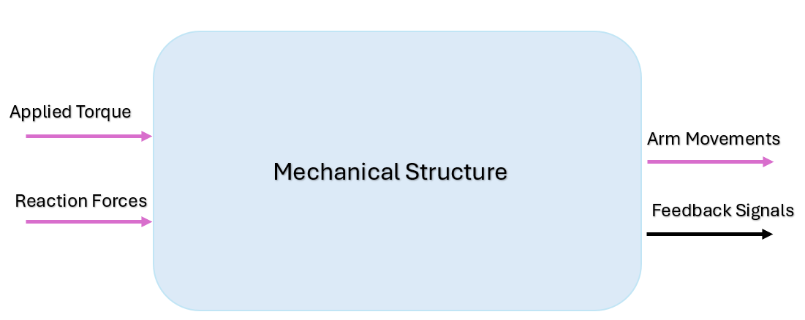

*Figure: Level-0 Design of Mechanical Structure*

| **Input** | * Applied torque * Reaction Forces |
| --- | --- |
| **Output** | * Movements of the robotic arm |
| **Functionality** | * Grabbing and re-locating chess pieces * Supporting and protecting other components and subsystems |

**Subsystems:**

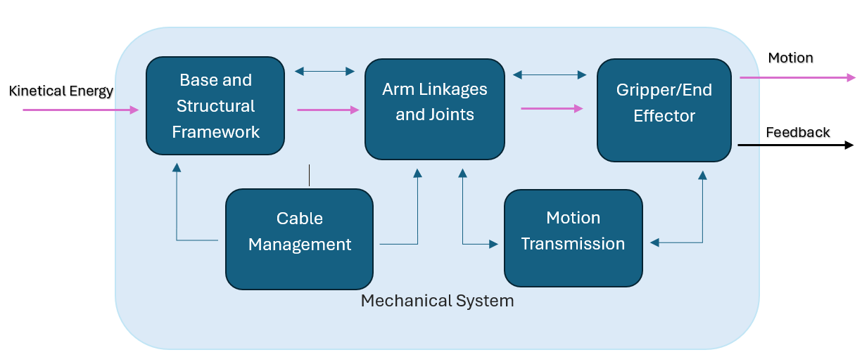

*Figure: Subsystems Of Mechanical Design*

## Power Source:

| **Input** | 220V-230V from a wall socket |
| --- | --- |
| **Output** | 5V - 6/12V regulated DC voltage |
| **Functionality** | Convert AC wall outlet voltage to safe, usable DC output voltages with enough current to drive all circuit subsystems. |

## **Electronics** D**esign:**

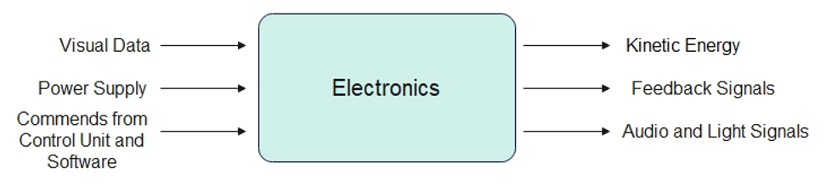

*Figure: Level-0 Design of Electronics Structure*

| **Input** | * Visual data captured by the camera * Power supply to provides energy to all components * Control signals from control and software unit |
| --- | --- |
| **Output** | * Kinetic Energy to move chess pieces * Audio and light signals to inform and guide the user * Feedback signals to the control unit |
| **Functionality** | * Tracking and validating the state of the chessboard and the moves of the user * Processing the game logic and sending control signals to the motors to move the pieces * Providing the feedback on errors, moves and game states to the user to guide and inform them |

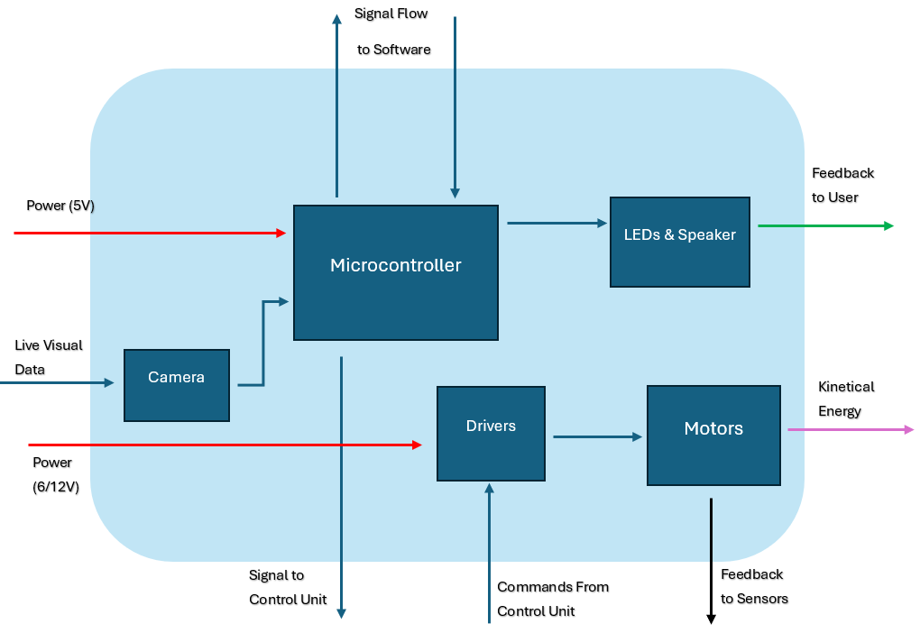

*Figure: Subsystems Of Electronics Design*

**Camera**

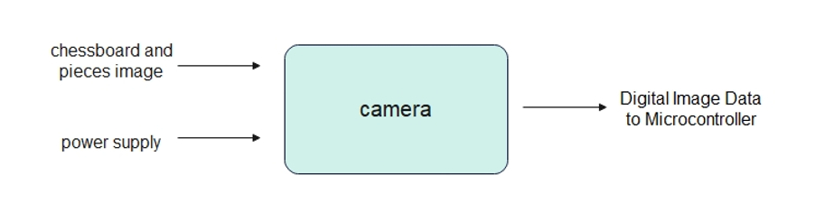

| **Input** | * Optical image of chessboard and pieces * Power Supply |
| --- | --- |
| **Output** | Digital image data |
| **Functionality** | Captures high-resolution images of the chessboard and transmits the images as digital data to the microcontroller for processing |

**Microcontroller**

| **Input** | * 5V 3A Power * Camera Visions |
| --- | --- |
| **Output** | * Motor’s Movement Signals (PWM Signals) * Vision Signals |
| **Functionality** | It provides minimum 5V 3A power and enables the movement of the motors to which it is connected and the processing of the images by monitoring the camera images it obtains. |

**Driver**

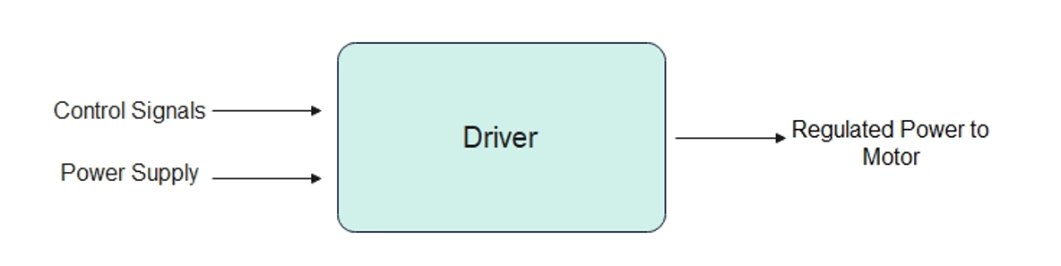

| **Input** | * Power supply * Commands from control unit |
| --- | --- |
| **Output** | * Power to the motor |
| **Functionality** | * Ensures that motor movements are smooth and controlled * Enables precise control on motors’ direction and speed |

**Motors**

| **Input** | * 6-12V Power * PWM Signals |
| --- | --- |
| **Output** | * Movement Signals |
| **Functionality** | It provides motor movement by processing the PWM signals received from the microcontroller. |

**Leds and Speaker**

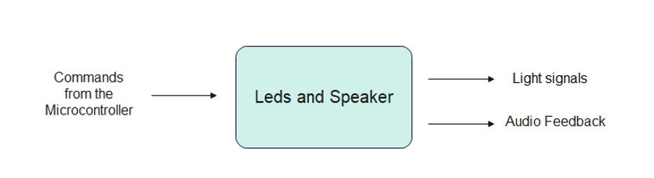

| **Input** | Command from the microcontroller based on specific game events or error |
| --- | --- |
| **Output** | * Visible light signals to the users * Audio feedback |
| **Functionality** | * Provides feedback to enhance the uses’ experience * Indicate game states to the users |

## **Software Design:**

**Subsystems:**



*Figure: Subsystems Of the Software Design*

**Object Detection:**



| **Input** | * Image Data Converted to a 2D Matrix |
| --- | --- |
| **Output** | * Array List of Chess Piece Locations * A Coordinate System on the Chessboard * Arm Translocation Data |
| **Functionality** | The image data received from the camera module gets turned into a 2D matrix on the microcontroller and then sent to the Object Detection algorithm for processing. The algorithm then takes this data to create an arbitrary coordinate system on the board, and using that, creates a list of where chess pieces currently are in the form of an array. The arm translocation data gets sent from the Object Detection Algorithm (Later to be used by the Sensors & Control Unit) when the arm decides to make its move. |

**Chess Engine & ML**



| **Input** | * Array List of Chess Piece Locations |
| --- | --- |
| **Output** | * ML Output of the Adjusted Bias Values for the Chess Pieces * A Warning Output In Case of an Illegal Move * Relevant Chess Strategy & Decision Information |
| **Functionality** | The Chess Engine takes the array list of chess piece locations and using its Machine Learning subcomponent, evaluates the best move to be done by calculating the available bias increases/decreases. After doing so, it sends the adjusted bias values and the other relevant chess strategy & decision information to the Microcontroller. If an illegal move is detected, it sends out an appropriate warning output. |

## **Control Design:**

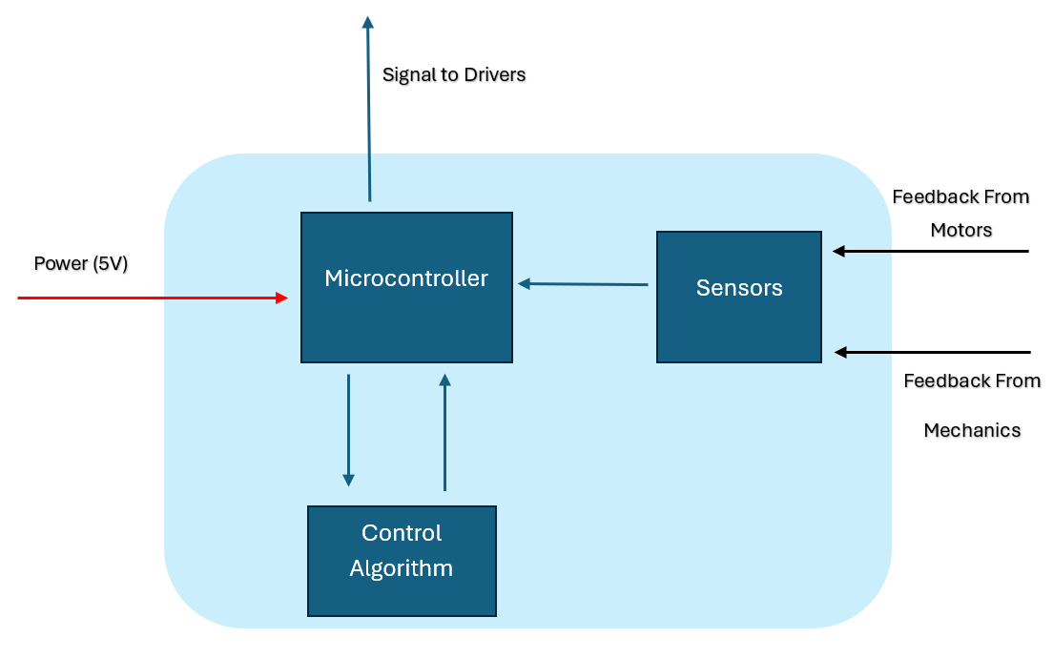

**Control Algorithm**

| **Input** | * The Location of the Chess Piece to be Moved on the Chessboard * The Position of the Robot Arm Relative to the Chess Piece |
| --- | --- |
| **Output** | * The Path Robot Arm Needs to Take * Motor Movements |
| **Functionality** | After the new chess piece locations are determined, the Control Algorithm receives the location data of the piece to be moved in a coordinate system format, relative to its own position. Then, it activates its internal motors in a required order for the arm to grab the piece and relocate it. After the robot makes its move, it returns back to its original position. |

**Sensors**

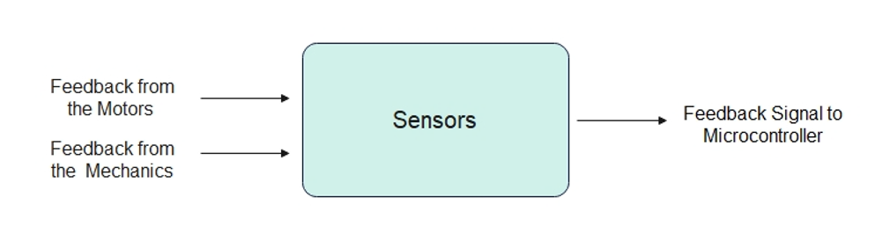

| **Input** | Feedback from the motors and the mechanics structure |
| --- | --- |
| **Output** | Signals to the microcontroller |
| **Functionality** | * It transmits the feedback received from the motor and the mechanical system to the microcontroller, allowing the next movement to occur. * Essential for detecting and correcting movements. |

**Microcontroller:**

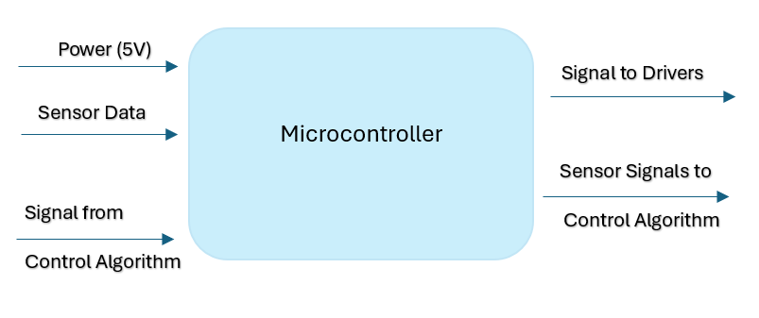

| **Input** | * 5V power from power supply * Data collected with sensors * Command signals from control algorithm |
| --- | --- |
| **Output** | * Control signals to motor drivers * Sensor data to control algorithm |
| **Functionality** | * Microcontroller contains embedded control software and enables this software to interact with other components * Collects data via sensors * Enables control with features such PWM |